To ensure functionality I performed two tests, one with correct credentials and one with incorrect credentials.

I did need to adjust mongodb:// client string to use authSource=admin since that’s what where we have our admin account created.

Tested Using Correct Credentials
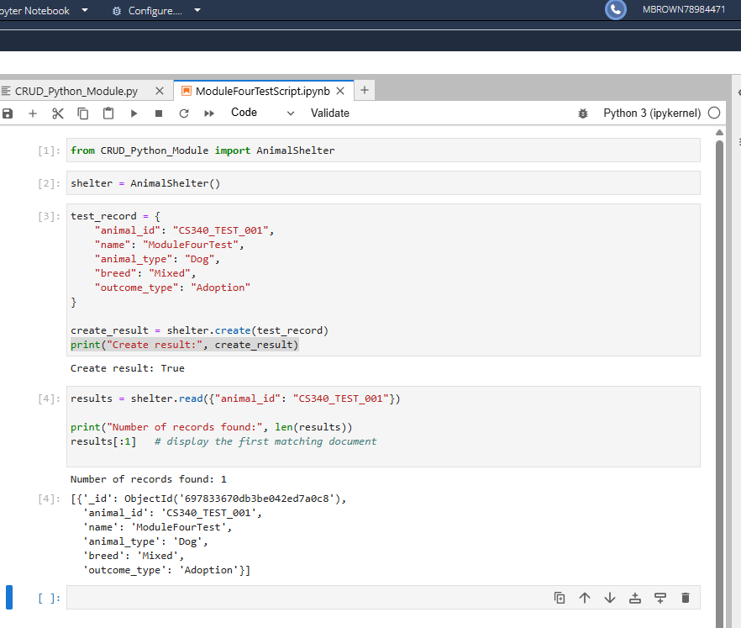

Tested Using Incorrect Credentials
